**Stage 1 - Initiation stage**

**Project Title** – Digitization of phonics and spelling in Education

**Prepared by** – Kalyani Joga **Date** – 01/10/2023

**Description** – Small infant school of approx. 100 pupils looking for a new phonics and spelling learning scheme after a dip in results. They have also recognized that the current computing offer in school is not adequate and would like to make improvements to both computing and phonics/spelling. They would like to do this by combing both of these and using a digital method for teaching phonics/spelling, utilizing tablet devices.

#### Project values –

* To improve the general teaching of phonics/spelling in school. For teachers to become more confident and feel successful. For support to be in place for teachers and an open and safe environment when it comes to staff discussing their own strengths and weaknesses and getting support for these.

#### Project objectives –

* To improve overall phonics/spelling outcomes for children
* To improve the Computing curriculum offer for children
* To identify common areas where children are struggling
* To design a curriculum to support these areas
* For the number of children passing the phonics screening check to be in line with national figures – 82%
* For the number of children achieving a scaled score of 100 or above in the reading SATS paper to be in line with national figures – 68%
* For all teachers to deliver quality first teaching in phonics/spelling
* To plan in adequate interventions for children that are falling behind expectations
* To prove digital home learning for children to access with parents
* To train parents in systematic synthetic phonics and spelling teaching

#### Scope

**–** We will roll out a new way of learning Phonics via technology by purchasing a ready-made phonics/spelling scheme that children can access via individual tablets. We are a small infant school, reception to year 2, with approx. 100 children across 4 classes. We will have one programme to use across the school, one set of class ipads to share across classes to begin with. We will provide adequate training for teachers, parents/carers and children to use the software and hardware effectively. The scheme will include a home learning element so that children can access and continue their learning at home.

* On the success of this project, the aim is to roll this out across the federation of schools, but we will not commit to this as part of this project. In the future we would also like to a set of ipads for each class rather than sharing but again that will not be part of this initial project.
  + **Objectives:** Please see the list above for the project objectives.

#### Restrictions:

There may be staff and parents/carers who are not confident using technology and may become anxious about this element.

There will be children that are unable to access the home learning element of this project due to lack of appropriate technology at home and therefore will be disadvantaged in comparison to their peers.

We will need to find additional funds through grants to have enough budget to complete this project due to small school budgets.

We will need to build a good enough case to prove to Ofsted that this method of teaching is the best for our students when they come to inspect the school.

#### Resource plan:

Key staff = phonics subject leader, computing subject leader, 5 class teachers, 8 support staff, 2 administrative staff, IT support staff (external company). The two subject leaders will manage the project including coaching other staff, monitoring progress. Other staff will support the roll out of the project to pupils.

Budget = £5000 from school budget, additional £9000 needs to be raised from external grants to fulfil predicted costs.

Other resources = school wide internet and intranet, space and equipment to train staff, dedicated training days and time within the school calendar.

#### Project requirements:

Cost of equipment/technology could increase before we are ready to purchase them. New initiatives from the government/Ofsted/school governors could take priority and delay the timeline of this project.

#### Key deliverables:

By the end of the this academic year (2023-24) all staff will have been trained and all equipment will be purchased, set up and ready to deliver to the children.

By the end of next academic year (2024-25) all children will have been accessing the new phonics learning via tablets in daily sessions and their progress will be measured at the end of that academic year (01/07/25). Data will be analysed and presented to governors on 21/07/25.

#### Change control process:

Any changes that need to be made throughout the project will be entrusted to be made by the two subject leaders after consultation and agreement from the Senior Leadership Team – this includes Headteacher, Deputy Headteacher and phase leaders.

#### Milestones –

Approval from school governors – 01/11/23

Scope shared with the whole staff team – 10/11/23 Project start date – 01/12/23

Date for all equipment to be up and running and ready to use – 1/05/24 Whole staff training – by 1/07/24

Start of teaching using the new technology – 2/09/24 Monitoring of teaching – ongoing from 1/10/24 Completion date – 1/07/25

Analysis of data/children’s progress data – 1/07/25

Report data outcome to school governing body – 21/07/25

#### Project risks –

* + Staff absence – long term. Staff missing the training, part time staff not working that day
  + Finding time in calendar for whole staff training
  + Children not having equipment at home to participate in home learning element
  + Connection issues in school – wifi strength
  + SEND children whom learning is not suited to
  + Staff not fully invested as other priorities
  + Accidental damage/loss of digital equipment
  + Teacher burn out
  + Ofsted unhappy with using digital learning
  + Impact on pupil progress

#### Resources/costs –

* + Product trainer to deliver training to staff
  + Training for parents/carers
  + Time to teach children to use the software
  + Cost of ipads/tablets for use in school
  + Tablets for disadvantaged children to use at home
  + Yearly subscription for a programme/scheme
  + Cost of equipment to store ipads/tablets
  + Cost of charging ipads/tablets
  + Cost to replace damaged equipment
  + Protective covers for ipads

#### Project restrains/constraints –

* + Opposition from teachers
  + Opposition from parents/carers
  + Lack of adequate budget
  + Lack of time to implement new scheme effectively

**Stage 2 – Definition and Planning**

#### Scope –

* + Staff training
  + purchase of resources
  + Teachers to implement in classrooms
  + Monitoring of impact in classrooms
  + Feedback from staff and parents/carers
  + Analysis of performance data

#### Budget –

* + Total cost budget approx. £14000
  + Funding from school budget £5000
  + Funding that needs to come from grants £9000

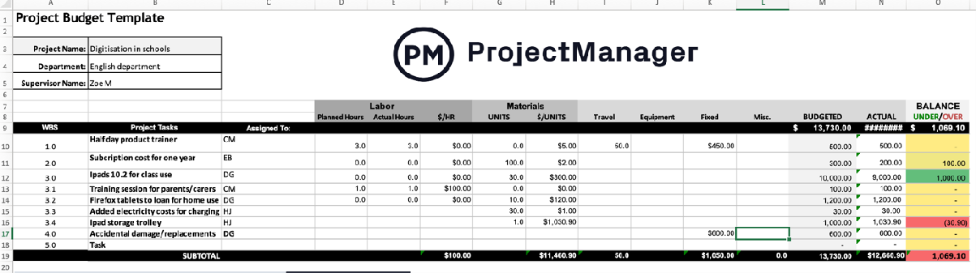

#### Work breakdown schedule –

* + Get external funding award e.g. Lincolnshire English hub grant
  + Purchase learning scheme and equipment
  + Train staff to use the programme and equipment
  + Staff to deliver this to children in classrooms
  + Subject lead to monitor implementation and provide regular coaching and drop in sessions for support
  + Subject lead to monitor impact through staff voice, pupil voice, lesson observations, test results
  + Subject lead to analyse data gaps to find improvements or tweaks to make
  + Lessons learned
  + Team celebration
  + Project closure

#### Gantt Chart–

* + Monday.com (see stage 3)

#### Communication plan –

* + Stakeholder identification/analysis
  + Subject lead to propose projects to Headteacher and governing body
  + Subject lead to report progress to governing body during termly governor meetings
  + Senior leadership meetings to talk about progress/risks twice per term
  + First ten minutes of weekly staff meetings to deliver short burst coaching
  + Drop in sessions in calendars for teachers to access support
  + Subject lead to observe parts of lessons/conduct learning walks and feedback positives and constructive criticism ideas to whole staff via email
  + Inform parents at various stages via ParentMail app

#### Risk management -

* + High – staff not fully invested

Time to implement project successfully Negative impact on pupil progress

* + Medium – staff long term absence/teacher burn out connection issues
  + Low – children’s lack of equipment at home Equipment damage/loss

SEND children access

## Monday task board

**Stage 3 – Project Execution**

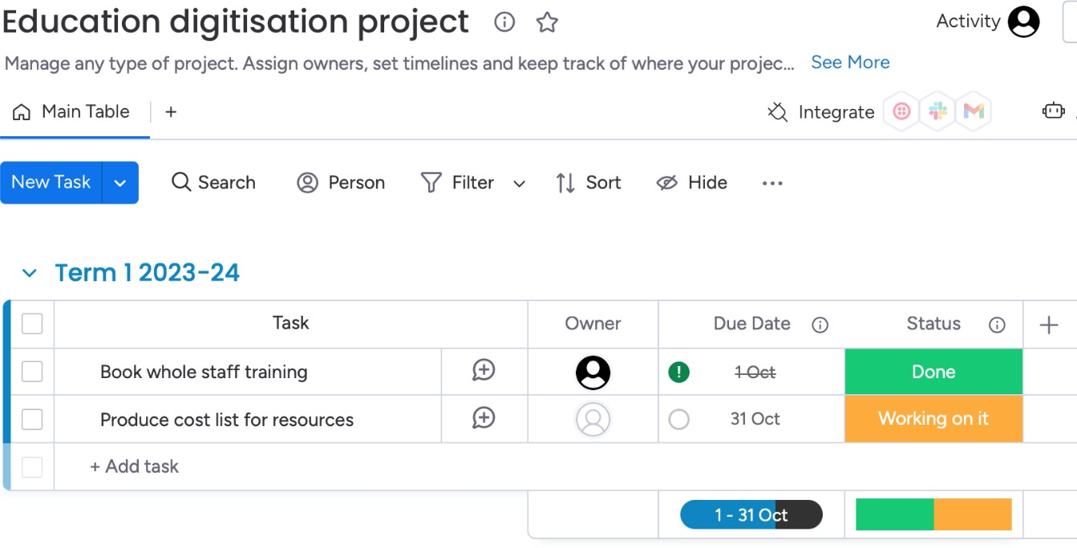

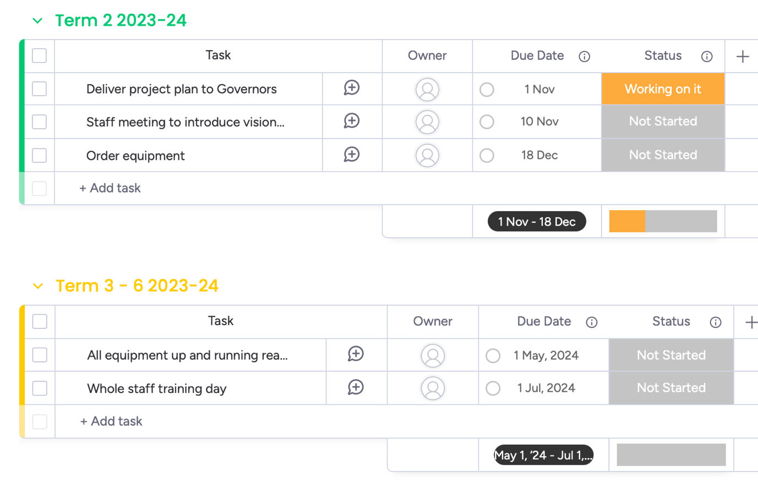

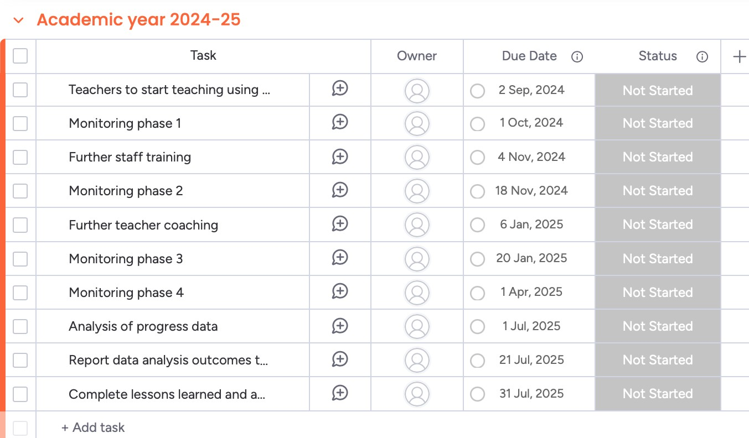

**Email communication regarding task completion**

|  |  |
| --- | --- |
| Communication with a team member who is on track with their tasks | Communication with a team member who is behind schedule |
| Dear XX,  Thank you for your continued contribution to the Education Digitisation project.  I can see from the Kanban board on Monday that you are up to date with your assigned tasks. I am very pleased to report that on communication with the key stakeholders, they are very happy with the progress and quality so far which is of utmost importance.  I see that you are currently working on X. As the deadline approaches for this task please get in touch if you require any support with this.  I look forward to our one to one meeting coming up next week, keep up the great work and see you soon.  Kind regards, Kalyani Joga | Dear XX,  Thank you for your continued contribution to the Education Digitisation project.  I have noticed on the Kanban board on Monday that you have missed a deadline and have a couple other deadlines to meet in the next couple of weeks.  If these tasks have been completed but you are yet to update the Kanban board please do so.  Please remember my door is always open so please let me know if you are having any issues and would like some support with the tasks. You are a very valued team member and I would hate for anyone in our team to be struggling.  I have opened up a one to one meeting slot for later this week if you would like to look over your remaining tasks together and work together to formulate a plan  going forward. |

|  |  |
| --- | --- |
|  | Kind regards, Kalyani joga |

RESOURCES AVAILABLE FOR EXECUTION

|  |  |
| --- | --- |
| **Resources** | **Additional information** |
| Staff | 1 staff member is on long term absence so we have seconded another member of staff from the federation |
| IT support |  |
| Staff cover for monitoring time | HLTA available to cover subject leaders |
| Set of 30 ipads and covers |  |
| 10 additional firefox tablets for home use |  |
| Ipad charging trolley |  |
| Product subscription for scheme | Yearly renewal |
|  |  |

DOCUMENTS TO BE COMPLETED

|  |  |
| --- | --- |
| Work breakdown structure | At start of project |
| Risk register and Issues log | Throughout the project |
| Budget tracker | Throughout the project |
| Project communication plan | At start of project |
| Resource management | At start/ongoing |
| Lesson observation/learning walk forms | During monitoring phases |
| Feedback forms | Ready for staff meetings/training |

COMMUNICATION PLAN

|  |  |
| --- | --- |
| Present project to governing body | Face to face |
| Present vision to whole staff | Face to face/email |
| Update staff as project progresses | Memos, emails, staff meetings |
| Update parents | Parentmail app memos |
| Update governing body as project progresses | Termly Governor meetings |

**Stage 4 – Performance and Control**

* [**Manage resources**](https://www.wrike.com/use-cases/resource-management/) – Equipment - regularly check that equipment is working

efficiently, have a system set up for reporting damage to equipment without blame. Staff – regular drop is sessions that teacher can access to get support from the subject leaders as and when needed.

* **Monitor project performance** – Use monitoring phases to observe what is

### happening in classrooms, speak to staff and children. At the end of the full academic year, data from the Phonics Screening Check will be analysed and reported to

Governors to demonstrate the impact of the project and whether we should continue with it the following academic year, what tweaks need making.

* [**Risk management**](https://www.wrike.com/project-management-guide/faq/how-to-manage-risk-in-a-project/) – Use a risk register to identify risks and keep track of what is being done to solve issues that have arisen. One high priority risk would be the

potential for a negative outcome on pupil progress. We will create an action plan for this that will show regular intervals for children to sit mock phonics screening check exams to monitor progress and identify any short comings that can be mitigated.

* [**Perform status meetings and reports**](https://www.wrike.com/blog/stress-free-reporting-with-scheduled-reminders/) – We have used an agile approach throughout due to the changing nature or education and this being a pilot scheme, this has enabled us to make changes where needed as we come across issues.

Regular monitoring phases allow for reports to be made and feedback to be given to staff to improve practise. Communication termly with governors to give progress

report.

* **Update project schedule** – phonics and computing subject leaders to update Kanban board on Monday to show when tasks have been completed. Kanban board overseen by Deputy headteacher.

**Stage 5 - Closure**

**Report findings to Governors** - report the performance data (pupil progress) in Phonics and Computing to the Governing body to prove the impact of the new scheme and gain approval to continue in the next academic year.

**Lessons learned:** Explore children performance data – create a lessons learned document to support an action plan for going forward with the project next academic year.

**Releasing the project resources and team members**: Staff and resources will not be fully released as such as the scheme will be continued to be implemented in future years; however, less monitoring and staff training will be needed which will free up staff to focus on other initiatives and curriculum areas for improvement.

**Archiving the project documentation and plans:** All documents to be archived into the appropriate file on the school’s one drive.

# **Project closure meeting** – Final staff meeting to share findings from the data and steps going forward in continuing the scheme next academic year.

**Celebrating the project success** – Lunch time finish for pupils on the final day of term, staff team to celebrate with a meal at the local pub. Speeches given to recognize and praise

individual staff members plus and verbal well done to the whole team for all of their contributions.